**北京化工大学**

**2019-2020-2学期期末考试试卷**

**课程名称：大学英语IV 课程代码：ENG１１４０３T**

**共 6 道题 试题总分 100分 答题时间：2小时 开卷**

**Part I Read the following passage and answer the following questions. (10 points)**

Twenty-five years after the release of the bestseller “Men are from Mars, Women are from Venus,” the debate over how and why men and women are different and what that means for their roles in society is far from settled. A new Pew Research Center survey finds that majorities of Americans say men and women are basically different in the way they express their feelings, their physical abilities, their personal interests and their approach to parenting. But there is no public consensus on the origins of these differences. While women who perceive differences generally attribute them to societal expectations, men tend to point to biological differences.

The public also sees vastly different pressure points for men and women as they navigate their roles in society. Large majorities say men face a lot of pressure to support their family financially (76%) and to be successful in their job or career (68%); much smaller shares say women face similar pressure in these areas. At the same time, seven in ten or more say women face a lot of pressure to be an involved parent (77%) and be physically attractive (71%). Far fewer say men face these types of pressures, and this is particularly the case when it comes to feeling pressure to be physically attractive: Only 27% say men face a lot of pressure in this regard.

When asked in an open-ended question what traits society values most in men and women, the differences were also striking. The top responses about women related to physical attractiveness (35%) or nurturing and empathy (30%). For men, one-third pointed to honesty and morality, while about one-in-five mentioned professional or financial success (23%), ambition or leadership (19%), strength or toughness (19%) and a good work ethic (18%). Far fewer cite these as examples of what society values most in women.

The survey also finds a sense among the public that society places a higher premium on masculinity than it does on femininity. About half (53%) say most people in our society these days look up to men who are manly or masculine; far fewer (32%) say society looks up to feminine women. Yet, women are more likely to say it’s important to them to be seen by others as womanly or feminine than men are to say they want others to see them as manly or masculine.

1. What is the name of the bestseller concerning the difference between men and women?

1. What aspect do men attribute the gender differences to?
2. What are the pressure points for women?
3. What are the pressure points for men?
4. What traits are valued most in women?

**Part II Read and write a summary within 100-120 words. (20 points)**

Requirements are listed as:

1. You should trace the historical change of women’s liberation according to the timeline: the ends of 19th century - 1960s - after the world war - the modern time.
2. You cannot copy the original sentences from the passage.
3. Your writing should be no less than 100 words and no more than 120 words.

We live in a male-dominated world. Although a few anthropologists still believe that before the beginning of recorded history societies were matriarchal – in other words, controlled by women – there is no evidence of this. Most societies we know are patriarchal: The man is the head of the family unit, and, by extension, the head of larger social organizations (such as industrial companies and governments) too.

But the role of women in society has changed enormously over time. From the end of the 19th century women began to achieve a political identity as they earned the right to vote in male-controlled countries – the first being New Zealand, in 1893. Today, women have the vote in almost every country of the world, and very few people would seriously contend that the exclusive role of women is just to stay at home and care for the family.

The movement which became known in the US in the 1960s as "women's liberation" can trace its origins back to the social upheaval created by the Second World War. With millions of men fighting abroad, women took over many of the jobs – such as factory jobs – which had previously been done by men. They had to. Otherwise industry, and with it the manufacture of military hardware, would have come to a standstill. Posters such as Howard Miller's "We can do it" (showing a woman known as "Rosie the Riveter" flexing her muscles) reflected this new-found role, and the message they communicated was clear: What men can do, women can do just as well.

After the war the growing feminist movement turned its attention to women's rights, and the removal of discrimination and harassment in the workplace. It was supported by a number of theorists, such as the Australian Germaine Greer, whose 1970 book The Female Eunuch rapidly became a best-seller, and the French novelist and intellectual Simone de Beauvoir. At the same time sexual liberation – linked to new contraceptive methods such as the pill – meant that women could increasingly take control of their sexuality, adding a further dimension to the concept of liberation.

Today, not many people would claim that women have exactly the same chances of getting ahead in a career as men with similar qualifications. But the tide is turning, confirmed by the steady flow of women reaching the highest possible positions in society, as heads of state or government. Leaders such as Indira Gandhi (India), Margaret Thatcher (UK), Golda Meir (Israel) and Angela Merkel (Germany), have left their mark on their countries and the world; more so, perhaps, than many of their male counterparts.

**Part III Describe the data within 60-80 words. (20 points)**

The table shows the number of outbound and inbound tourists from the year of 2015 to 2019 in China. Describe the data and make a prediction based on the data provided.

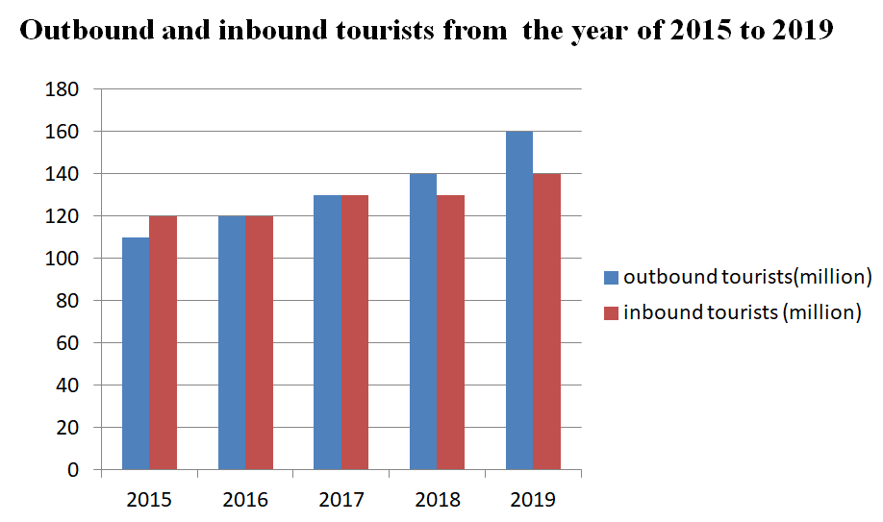

Outbound tourists:出境游旅客

Inbound tourists: 入境游旅客

**Part IV Translate by using phrases provided within 100-120 words. You can get full score only if you have used all these phrases correctly in translation. (20 points)**

简历是通向面试的市场工具。通常，并不是那些最佳的人选获得面试机会，而是那些最佳简历的拥有者获得面试的机会。简历给人的第一印象很重要。好的简历逻辑性强，重要信息易于获取和阅读，与特定的某类工作关联性强，信息准确，避免错误信息或夸张的论断。简历具有职业差异性。艺术家的简历可能列出一长串艺术展或公开演出的信息，而学者的简历会列出自己发表的文章，出版的书籍以及获得的研究基金。

open the door for, not necessarily, attend an interview, accessible, relevant to,

exaggerated claims, vary, long lists of, published, research funding

**Part V Read the following passage and fill in blanks with words from the passage. (10 points)**

In 1992, in the small town of Maastricht in Holland, the 12 members of the European Community (as it was then called) took a major step in the direction of economic union: They introduced a single currency, the euro. It marked the beginning of the European Union. Two countries (Denmark and the United Kingdom) decided against the adoption of the euro. For the other members, a process began which led to the first euros appearing in people’s pockets ten years later, on the 1st of January 2002, replacing the French franc, the German mark, and other historic currencies across the continent.

The idea behind the euro was to create the conditions for macroeconomic stability, as well as making life easier for citizens travelling within Europe, who no longer had to worry about changing money between countries (and paying charges to do so). The experiment was a success. After a shaky start the euro began to stabilize as a major international currency, growing in strength against the US dollar and sterling. Today the European Union numbers 27 member states, most of which have adopted the euro.

But one problem facing the EU was the design of coins and banknotes. The sign for the currency, itself -€- was uncontroversial. But, in a relatively small continent with considerable cultural and linguistic diversity, what symbols should be chosen to represent a shared cultural heritage? In the end, it was decided that coins would have a national side, which would features a symbol of the member country in which it was issued, and a map of Europe on the “Common” side. Banknotes, however, would be different. They would be exclusively “European”.

A competition to design the banknotes was won by an Austrian artist, Robert Kalina. His idea was to capture the spirit of the new Europe through images of gateways and windows (symbolizing openness and welcome) and bridges (a metaphor for communication between cultures). But instead of using existing European monuments, he chose abstract designs of major architectural periods which have left traces throughout Europe. Thus the €5 note illustrates the Classical Period, the €10 features a Romanesque bridge and doorway typical of the 12 th century, and the journey through time and architecture continues with Gothic (€20), Renaissance (€50), Baroque (€100), the glass and iron of the Art Nouveau style (200), finally reaching the modern age in the €500 note.

1. From the passage, we know that __________________ denied using euro as the currency in their countries.
2. Before Europe adopting euro, people in different countries had trouble in __________________________.
3. The difficulty in designing euro lies in choosing a sign to _____________________________ with the existing diversity in Europe.
4. Euro coins are designed to integrate both specific national feature and shared European feature together, with a sign of the member on one side and _______________ on the other.
5. _________________________________ are used in banknotes to symbolize the spirit of the new Europe.

**Part VI Write with guidelines within 120-150 words. (20 points)**

Some people think we dress for comfort, but others claim that we dress for fashion. What is your opinion? Write an essay with the following points as guidelines.

1. Make your statement on the issue
2. Provide reasons for your statement
3. Make conclusion for your essay